Treadle Lathe
http://www.bob-easton.com/blog/category/treadle-lathe/
Bob Easton
1/31/2014

Version 2.0

Table of Contents

1. You’re Gonna Build a What?............................................................................................pp. 3 – 5

2. The Wheel………………………………………………………………………………...pp. 5-6

3. Plans and Lams…………………………………………………………………………....p. 7

4. Plans…………………………………………………………………………….…………pp. 7 – 9

5. Lams…………………………………………………………………………….…………pp.10-11

6. Makin’ Parts………………………………………………………….……………………pp. 11 – 13

7. Wordless Wednesday……………………………………………….……………………..p. 13

8. Feet…………………………………………………………….…………………………..pp. 13 – 14

9. Gams, Mortises and Tenons…………………………………………….…………………pp. 14 – 17

10. Resume Building……………………………………………………….………………...p. 17 – 18

11. Mount the Wheel……………………………………………………….………………...p. 19

12. Bearing Blocks………………………………………………………….………………..pp. 19 – 20

13. Parts………………………………………………………………………………………pp. 20 – 21

14. Puppet/Tailstock……………………………………………………….…………………pp. 21 – 23

15. First Turning – a 24 inch object………………………………………..…………..…….p. 23

16. The Treadle Mechanism………………………….……………………………...……….p. 24

17. Treadle and First Turning…………………………………………………………………p.25

18. Machined Crank Details…………………………………………………….…………….pp.25-27

19. Spindle………………………………………………………………………….…………pp. 27 – 28

18. Drivin’ It………………………………………………………………………….……….p. 29

19. Tool Rest and New Pulley ………………………………………………………………..pp. 29 - 32

20. Adjustable Tool Rest………………………………………………………………………p. 32 – 33

21. Notes…………………………………………………………………..…………………..pp.33 - 35

Overview
From: http://www.bob-easton.com/blog/category/treadle-lathe/
Overview: The plan, the design choice, construction details, and various improvements.
As with most projects, this one was not built strictly to plan. I already have a huge bench, so did not include the bench details from Shepherd’s plan. The rest is upgrades to modern bearings and other simplifications because the local blacksmith left long ago.

You’re Gonna Build a What?
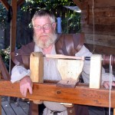
Preserving history at the Kansas City Renaissance Festival
A lathe, my dearest, an ole time treadle lathe.
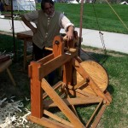
Re-enacting at Fort Osage Missouri
We looked at some pictures a while. She said “Sure, get to it … but, if you show up in one of those costumes…”
These top two photos are thanks to Jerry who preserves history by working with the Institute for Historic and Educational Arts in Kansas City. THANKS Jerry! (As always, click a small picture to see a larger version.)
It’s still too cold in the shop for epoxy based boat building, and another 5 inches of “global warming” just fell today, I’ve been considering two other woodworking paths.
Beautiful old clocks (or replicas), complete with mechanical movements, are things I have built in the past and have considered for the future. Previous clocks were built from kits. I would like future cases to be built from scratch. I fancy clocks such as regulator wall clocks, and Vienna Regulators. As near as I can tell, some of those would require a half set of hollows and rounds, a plow plane, and maybe a pair of snipe bill planes. The wait queue at Clark & Williams, as well as the cost, make that path one that won’t be taken this winter.
So, let’s pursue the alternative, the lathe. Why a human powered lathe?
- Because I like human powered things, hand-tool woodworking and paddle powered boats, for example. Treadle powered tools have always caught my attention, and now I have time for them. In short, I see a treadle lathe as a neat machine.
- There’s no shortage of turned things I find interesting: mallets, tool handles, more tool handles, toys, lidded boxes, chairs (not Windsors), and exquisite wooden bowls. I’m not interested in pens or bottle stoppers.
- The lathe will also be the power base for a scroll saw. I have some very interesting scroll projects in mind.
To which design or plan? Choices, choices, lots of choices on the internet. I collected several comprehensive plans (Roy Underhill’s, Steve Schmeck’s, Mike Adams’ and Howard Ruttan’s), and plenty of pictures. All have great merit, and I will build not to one specific plan, but will take bits from here and there. From Roy’s, I will take the concept of the scroll saw. His lathe has one aspect I didn’t care for, an inboard flywheel. It was also skimpier that the lathe he uses on his TV Programs. Mike’s and Steve’s are more robust and have flywheels held between two uprights, not cantilevered like Roy’s. I like the full width treadle of Mike’s, and actually a sturdier one like in the Ft. Osage picture at the top. Guidance for bearings, various shafts, and centers come in bits and pieces from all of the plans and from an email exchange with Jerry.
The attractive feature (to me) is that any of the above designs can be made from readily available “Nbr 2″ construction grade SPF (SprucePineFir) lumber. The big orange store up the road has some fairly good Doug Fir that I’ll use for most of it. Some Ash or Oak will fill certain roles.
Oh, for those who like the idea of a treadle lathe but would rather not build one, Chris Yonker makes beautiful lathes and sells them through his CME Handworks eBay store.
OK. It’s time to get to it.
UPDATE: When I wrote this entry this morning, I was getting a 404 error when trying to reach Mike Adams’ Treadle Lathe Plans site. That site is still not responding, but I have found an alternate source for his plans.
UPDATE 2: Stephen Shepard suggested (in the comments) another set of plans that I had overlooked. They are Stephen’s own plans which are sold by Joel Moskowitz’s excellent Tools for For Working Wood store. You’ll find Stephen’s plans here.Â TFWW always ships very fast and I live close enough to expect receipt in the next day or two. Thanks Stephen.

The Wheel

The one point of agreement in the many plans I’ve collected is having a flywheel of 24 inch diameter. Construction varies with the different plans, some with interesting spokes and rims, some solid. I chose solid: easy. I like easy. It wants to be a substantial wheel, the heavier the better. Two layers of 2-by lumber would do it. However, that would leave a seam in the middle of the wheel. What if I decide to drive it with a cord rather than a flat belt. Wouldn’t that seam invite trouble as a gutter is routed for the cord? To avoid that eventuality, I used 2-by material for a middle layer, and then attached 1-by material on either side. Yellow carpenter’s glue and a bunch of countersunk screws bring the layers together, each offset by 60 degrees.
Now, let’s make it round. I really really really like doing as much as possible with hand tools. I have a great turning saw that uses Gramercy blades. However, this wheel presents 3 problems. First, the coarsest Gramercy blade is 10 TPI and 1/8 inch wide. That seems a bit skimpy for this cut. I would prefer 6-8 TPI and 1/4 inch wide, a size not available. Second, a wheel really needs to be round with a nicely perpendicular edge, something I imagined hard to achieve by hand. Third, I don’t have enough Snickers bars on hand to power that much sawing.
So, it’s time to dust off the band saw … and extend its table. It didn’t take much to knock together a one-time use table extension that has a pivot hole 12 inches from the blade. It took longer to find the screws than to make the extension. The table on this Rigid saw has holes tapped for 6mm by 16 screws. How many of you can find 4 of those in your loose parts collection? I did.
There it is, a simple wheel. It weighs 24 pounds. I don’t know if that is heavy enough.
Oh, before I quit, let me show you one very sweet hand drill bit. I learned from my fellow galoots over at the Saw Mill Creek forums that it might be a Cook (US patent) or Gedge (UK patent) pattern. Most of the hand drill bits we see these days are either Russel Jennings or Irwins, with spurs pointing toward the tip. This bit has the spurs turned back toward the shank. It makes a very easy entry, and better yet makes a very clean exit. There’s no tearout at the exit; no need to stop before exiting and drill back from the other side. It seems that Ransom Cook patented this pattern a few weeks before Jennings, but maybe didn’t have as good a marketing department. The Jennings bits prevailed.
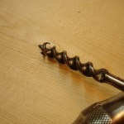

Chasing another of the patent references made by Jeff in the forums, I see a patent by James Swan, some 20 years after Cook’s. Swan’s improvment was to extend the cutting edge from out at the curl all the way into the screw. My bit is indeed a Swan. This one came to me as one of a handful of odd bits that Patrick Leach threw in the box when I bought the Stanley brace. It’s the only one of that pattern I have. After using it, I’m wanting more.

Plans and Lams
The last 15 years of my previous career were spent in the world’s finest commercial research laboratory. From there, I learned a method of working that leads me to do a good bit of research at the start of a project, to learn a great amount about a subject before starting the actual work. I continue that practice with my woodworking projects, often collecting many more plans and articles than one could ever use, and then building to none of them.

Plans
My first article about building a lathe touched quickly on the sources of a few plans for lathes. By “plans,” I mean publications that include measured drawings or enough detail to be useful as construction guides. Here are a few more details along with some of my opinions.
- Roy Underhill’s treadle lathe article describes a lathe built from discarded lumber salvaged from the dumpster outside a university dorm. This article comes to us compliments of the Woodworking magazine blog, originally published in the October 200 issue of Popular Woodworking magazine. Underhill’s usual humor augments the constructon details for a lathe is smaller and lighter than the one Roy often demonstrates on Woodwrights Shop TV program. It fits very well with the idea of using standard size construction lumber and has a number of features that simplify construction, such as connecting the pittman arm directly to the flywheel instead of fabricating a metal crank. While a nice feature, it requires the flywheel be cantilevered, and I wonder about the durability of such an arrangement. An appealing added feature is a lightweight scroll saw attachment. I definitely want to use this idea, but will build one a lot more robust.
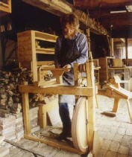

- All in all, this is a fine article with a very complete cut list, good instructions, and a bit of Roy’s humor. It strikes me as a fine “starter” treadle lathe. There’s also a Sketchup model here.
- Steve Schmeck keeps a website covering a variety of topics, many of them environmentalist in nature. His lathe plans have been available for several years. Steve’s lathe is quite a bit like the pictures published in the first of these lathe articles, substantial in size, but still manageable for transport in his van. It lacks the diagonal braces shown on some designs. An added feature of Steve’s lathe is an optional tension adjuster that alleviates the chore of resewing a stretched drive belt. Like all of the lathes I considered, construction is from construction grade lumber with hardwood mixed in where you think appropriate.
Since Steve’s plans are in a book (eBook(pdf) or CD) that need be ordered, you can see a few pictures without buying at a page where Steve shows a few lathes built from the book’s plans.
You bike riders might want to check out Steve’s homebuilt “Woody” recumbent bike. Yep, a wooden bike.
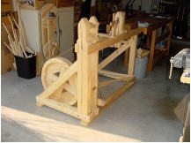

- Mike Adam’s lathe is somewhat similar in size and construction to Steve Schmeck’s. He does the various bearings and the crank a bit differently, housing bearings in hardwood inserts. His foot pedal is a full width frame, not just a single board as in the previous designs. Being a bit klutzy, this wider pedal holds appeal for me. Mike’s spoked wheel looks great, but he admits it was too difficult to construct and needed additional balancing once done. That’s why I decide on a solid wheel. Mike posted a YouTube video showing it in action.
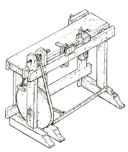

- Followers of Stephen Shepard’s Full Chisel blog will recognize Stephen as a restoration specialist and expert artisan for nineteenth century woodworking (from the turn of the century until “the unpleasantness between the states”). Stephen’s plans are available from Joel Moskowitz’s excellent Tools for For Working Wood store. You’ll find Stephen’s plans here. True to form, Stephen’s plans are excellent, drawn from an 1805 exemplar. They are very complete, comprising eight 11″ by 17″ plates and 4 pages of commentary. This lathe is distinctly different from the others, being a combination lathe and workbench. The wheel is more forward, pivoting from within the headstock uprights instead of from diagonal braces further back as in all the other designs. A bench surface extends rearward for 12 inches beyond the spindle centerline and is the full width of the lathe. A small vise attaches to the back edge of the bench. It is a clever design for those pressed for space. Also interesting are the several purpose built, hand wrought, chucks. They appeal, but will require finding a blacksmith.
- Lastly, I referred to web material by Howard Ruttan. His is, alas, not a set of plans, but a comprehensive FAQ with yet more links to research.

Lams

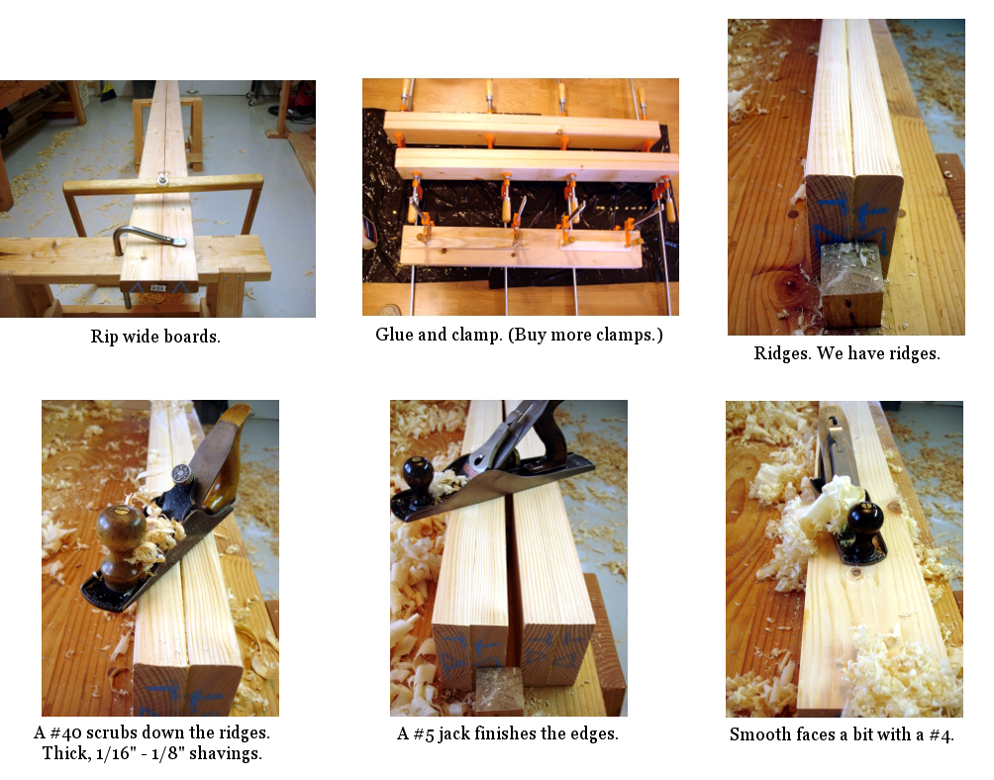
Many of the lathe components need to be thicker than typical construction lumber. Thus, we laminate. My nearby home center stocks the usual number 2 lumber that’s useful for framing. Like most of this stuff, the narrower pieces are the worst available, often being milled from trees barely large enough to contain a single 2×4. I buy much wider boards and rip them to the widths I want. One good feature of most of their lumber is that it is reasonably dry and does not need a lot of acclimation. The lamination process is simple. It consists of these steps:
- Plane the intended faying surface enough to ensure a good join. This is most useful to remove cupping; planing only the faces that will join each other. The jointer plane is your friend here.
- Rip.
- Glue and clamp (currently using yellow carpenters glue). When laminating, ensure stability by having the outer edges of the board, the edges toward the bark, face each other. The end grain should look like this: )))(((
- Plane off the crowned edges (if any), using first a scrub (#40) and then a jack (#5).
- Remove most of the surface uglies with a smoother (#4).
Effort and energy cost: about one Snickers bar per 10 foot lamination.

Makin’ Parts
Overnight temperatures in the workshop are slowly rising toward the minimum needed for epoxy work. Spring might be coming. Song birds are returning their joy to the neighborhood. Boy are those babies getting a surprise today. We have 12-18 inches of crystalline global warming falling from the skies today and tomorrow. So, work continues on the treadle lathe.
When I was making the flywheel, I doubted the ability of my trusty turning saw to do a good job with the wheel’s thick stock. I wimped out and used the bandsaw to ensure a round wheel. Wanting ogee curves on the tops of the headstock and tailstock posts, I decided to give the turning saw a try. These posts are the same thickness as the wheel. The only difference between these cuts and the wheel was the level of perfection needed. It turns out that the saw, using the 10 TPI 1/8″ Gramercy blade, acquitted itself quite well.

On a piece of cardboard carton (empty pasta box) I drew a curve that pleased me. I traced around that to position the pattern on both sides of all three of the parts. Sawing close to the line was not at all difficult. Yes, it was slow going but cost only a couple of Milky Way bars. A Nicholson 2nd cut cabinetmaker’s rasp was my tool of choice for completing the shaping.
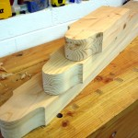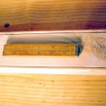
Boatbuilders often use beading to dress up the plain parts of small boats, usually the thwarts. The beading shows good craftsmanship and also eases the comfort of bare legs sitting on the thwarts. Stephen Shepherd recommended beading in his lathe bench plan notes. So, I want to use beading on some of the parts. Having never done it, I researched (of course), and determined a scratch stock is the tool of choice for such work. More research found me many ways of building a scratch stock tool. I ended up eliminating all but two, a design by Tom Casper in the October 1999 issue of American Woodworker (a bunch of them online thanks to Google Books), and a design by our beloved Village Carpenter, Kari Hultman.
As much as I like the simplicity of Kari’s approach, I thought the design with two reference surfaces would be easier to control. I made it from a bit of Ash. The basic “L” shape was cut first. Then, I fitted the screws, removed them, and resawed the tool into two pieces. Rounding the long fence face, and rounding over all the other edges completed the stock. The scratch blade is a bit of saw blade cut to a small square and then filed with a rattail file.
It works surprisingly well. It’s a good way to improve the appearance of this marginally acceptable lumber. Now, the real reason for beading is to strengthen the part. A piece of lumber with sharp square edges is subject to splintering as it transitions through humidity changes. Splintering leads to splitting. Splitting leads to twisting and warping. Knocking off the sharp square edge significantly lessens the potential for splintering and all the rest. Hence, strengthening the piece, while making it more attractive.

Wordless Wednesday

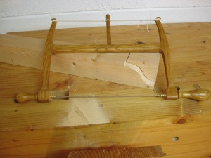

Feet
Sunday, March 14th, 2010
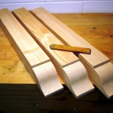

Work on something else while epoxy cures on the boat, or while waiting for the shop to be warm enough for epoxy work.
Bookmatched laminated Douglas Fir construction lumber can be made to look reasonably decent. The bookmatching here is the result of ripping a 2×8 directly along a center line and folding it in upon itself to laminate. The top surfaces of these feet are the new edges exposed by the rip.
Yes, same curves on the other ends.

Gams Mortises and Tenons
Sunday, March 28th, 2010
We’ve had plans and lams. And now we have gams. OK, legs … and maybe some feet too.
Before I get started showing how I made rather big mortise and tenon joints, let me preempt a question. Someone is bound to ask why I didn’t make much easier half-lap cuts in some pieces before I laminated them. They would be so much easier than cutting big mortises. Simple answer: when I started laminating parts, I had a good idea of general dimensions, but had not yet decided on which style of lathe to make. Should it be one with the wheel sitting back behind the ways, or one with the wheel centered on the headstock? They have completely different construction.
I’ve decided. The lathe will have the wheel centered on the headstock, similar to those by Steve Schmeck and Stephen Sheppard (see the Plans and Lams entry). This makes the contraption a bit more compact while simplifying construction.
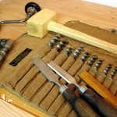

This part of the work started several months ago with tool acquisition. No, I don’t think I’ll ever need huge mortising chisels more than once, so I didn’t look for them. I did look for, and took a good long time watching the market, a set of Russell Jennings double spur auger bits. A set of these pops up on eBay about every 4 days. A set is 13 bits ranging from 3/16 to 16/16. They are packaged in either a 3 tier wooden box or a canvas roll and date to sometime prior to 1944 when Stanley bought out Russell Jennings. The eBay offerings are often missing one bit and range from mediocre to almost unused condition. Prices vary accordingly and are remarkably predictable if you watch for a while. I waited until I found a complete set that needed only a little cleaning and was lingering around with no bids. My one bid brought it to me at a price I clearly liked. Overnight in some white vinegar cleaned the bits up to near new condition. All were sharp. The smallest was a bit bowed but easily straightened. The chisels in the photo are Narex bench chisels, great value at an affordable price. The mallet is shopmade from black locust.
The uprights / legs are 5 inches by 3 inches in cross section. The feet are 3 inches by 3 inches in cross section. I’m not a tenon engineer and don’t know the optimal size for this application, but I decided to make the tenons 1 inch by 3 inches in cross section, and of course three inches long. Mortises first, or tenons first? I did the mortises first. If one were to do a lot of these, a great big 1 inch mortise chisel would be the tool of choice.

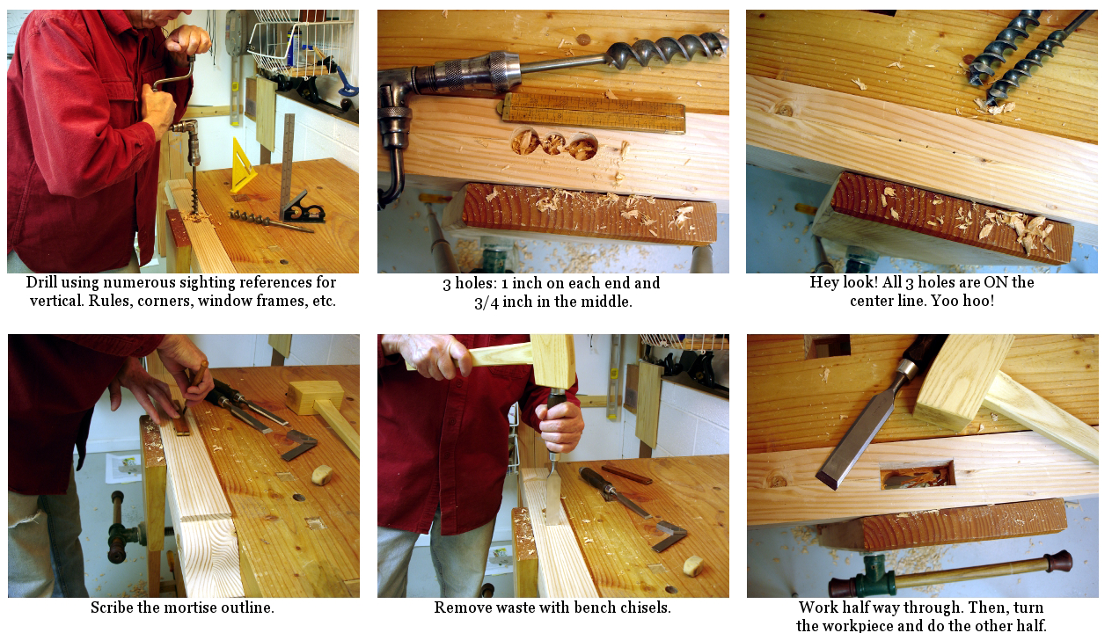

I don’t think I’ll be making many more, so drills were my choice. Layout was easy since the centers could be placed on the lamination line. Just find the center of the workpiece and layout the 3 inch extent of the mortise. Drilling by hand, without a drill press, needs a bit of practice and several sighting references. It’s really not too hard to make holes that are vertical within the precision needed. Drilling by hand does have some limitations. One cannot overlap holes as can be done with a drill press. Even getting two holes close together can let the bit cut through a thin wall into the nearby hole and “drift” astray. I drilled two one inch holes, one at either end of the mortise and a 3/4 inch hole in between. When working with spur bit augers, the practice is to drill until just the spur starts to exit the far side of the workpiece. Then, turn the piece over and complete the hole from the other side. This technique makes a nice clean hole with no blow out. Waste removal was now a small enough job for bench chisels. Mark a very clean outline. Chisel away waste until half way through. Turn the workpiece and repeat.
The last large tenons I made were for the stretchers for my workbench. They are serviceable, but not pretty. My sawing skill is slowly improving and I think I can make better tenons than before. Yet, I decided to try a technique that I saw on Steve Branam’s “Close Grain” blog. He did a riff on a Chris Schwarz technique using a simple jig and a ryoba saw. It works well, as the picture shows. I varied from the technique Steve shows by using the reflection technique to make the absolutely square shoulder cuts. Note how the edge of the workpiece reflects in a straight line on the saw plate. I added a blue line in the photo to highlight what to look for.
This cut, by the way, is a first class cut and needs to be very clean. Although I don’t show it in the pictures, I marked the cut with my wonderful Czeck Edge marking knife and then reinforced that marked line with a shallow chiseled “V.” That provides a starting notch for the saw while keeping the edge very crisp.
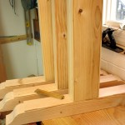

The ryoba saw is a simple one from the BORG, inexpensive and useful. I saw a question posted in a forum recently from a guy with analysis paralysis on how to best spend $100 for a new ryoba saw. He got no answers while the rest of us are busy cutting up lumber.
The joints fit together very nicely, snug, not sloppy. They will be completed with hot hide glue and drawboring. Lot’s of people have written about drawboring, so I won’t repeat all that here. It’s simple and it works.

Resume Building
Thursday, September 6th, 2012
Building a treadle lathe started a long time ago, when the shop was too cold for epoxy to cure on a boat I was building. A lot of water has passed under our boats since then. Other activities, swimming, language learning, travel, and various forms of woodcarving have also happened.
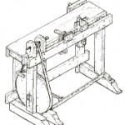
So, why back to the lathe now? Simple, some of the woodcarving I want to do is on various turned objects.
Quick recap: Plans are abundant. Making choices depends on intended use and can lead to analysis paralysis. My intended use does not include dragging the thing around to festivals, to shows, or any form of re-enactment. Out with the period costumes, and actually out with some of the other period authenticity.
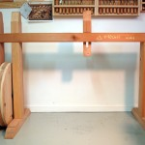

The lathe is intended for practical use and I’ll certainly be using modern parts such as ball bearings, chucks and live centers.
My choice of structure most closely resembles Stephen Shepherd’s 1805 “Moses T” lathe, but without the bench behind the ways. Mine is also heavier in certain areas, mainly the uprights and feet.
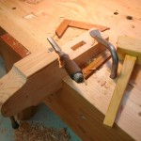

The last we saw of the build had the bigger parts mostly complete, the uprights, feet, wheel and rough tail stock. All of it has been set aside in the shop and has shown no signs of checking, splitting, warping etc. Not bad for construction grade lumber. The photo of assembled parts is showing only a dry fit. Nothing is fastened to anything else. … and what looks like a piece of lumber much longer than the lathe is really a french cleat attached to the wall behind the lathe.
Recent work includes getting the tail stock to fit between the ways. That was basic tenon cutting. After that, I hacked out a through mortise that will later house a wedge.
Next up: A bevy of smaller parts for the treadle, or getting that wheel mounted between the uprights? hmmmmmm…

Mount the Wheel
Friday, September 7th, 2012
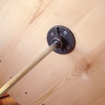
One of the hard parts of preparing the flywheel was done a long time ago, before cutting it round. The wheel rotates on a 1/2 inch axle. I drilled the center hole and then used that hole as the pivot point for cutting the perimeter on the band saw. Nice! Guaranteed center for the axle.
Here, we see the axle mounted. I used the ever popular plumbing flange on both sides of the wheel. The purpose of this flange is to connect the wheel mass to the axle. That is done with a simple 9/64″ hole drilled through the axle and a common “8 penny” nail through a pair of holes already in the flange. Simple. Snug. Done! (Oh well, almost. The axle will be cut to length later.)
Yes, there’s a matching flange on the other side of the wheel. No pin through it; all we need is one. The real purpose of that flange is to provide a bearing surface for the washers that will keep the wheel centered between the uprights. You’ll see those later.

Treadle Lathe – Bearing Blocks
Sunday, September 9th, 2012
Other people who have added modern bearings to their wooden treadle lathes report the bearings eventually moving around and becoming wobbly. The solution is housing the bearing in something harder than the typical softwood we use for the lathe frames. Let’s see now… oak, ash, … ah, there’s some walnut left from a gun stock project. There’s enough walnut for the bearing blocks and for a few other small parts. Perfect.
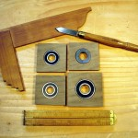
There are a total of 4 bearings, two 1/2″ for the flywheel and two 5/8″ for the headstock. One of the 5/8″ bearings is a thrust bearing that will absorb the headstock’s lateral movement. They have outside diameters of 1 and 1/8″ and 1 and 3/8″. Forstner bits in a hand brace do the job. I drilled several holes through a block that’s a bit more than twice as thick as the bearings. Then, I sliced the block into the correct thickness. It’s a simple resawing task, but the work pieces were too small to handle well for manual resawing. So, I relented to using the band saw. After that, saw to size with a Japanese pull saw. Yes, I’m leaving them square. It’s easier than making them round.
By the way, I can’t say enough good things about my Czeck Edge marking knife. It’s really hard to mark dark woods for sawing. Pencil lines disappear. Pen lines are too fat. The marking knife makes perfect lines that are both precise and very visible.
P.S. I’ll be remaking the block for the thrust bearing. I’ve decided to double up on that one by placing the thrust bearing and a regular bearing sandwiched together. It’s a simple matter of more boring boring.

Parts
Tuesday, September 11th, 2012
These are the parts not commonly found at your nearby home centers. We’ll see more of them in subsequent posts.
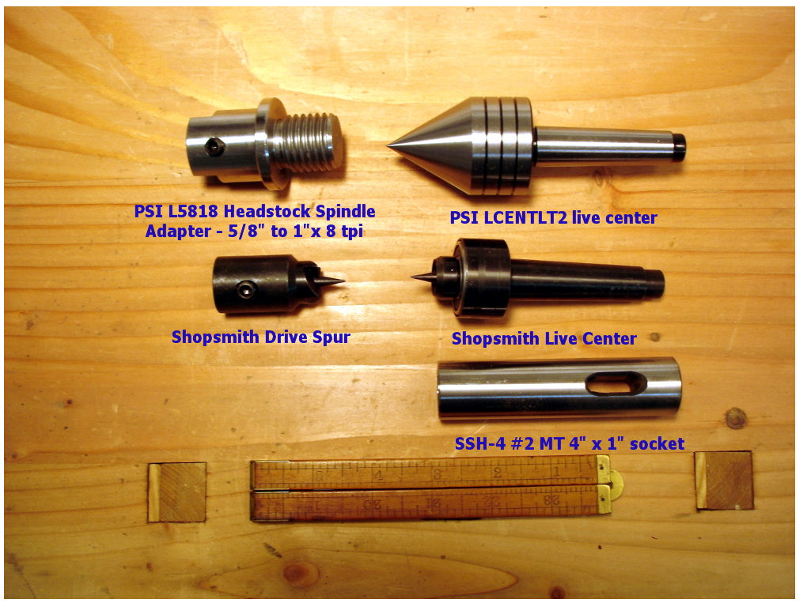

Some of these are available from several sources. I include links in the “Source” column for where I found the ones I’m using. Shop around. For example, that MT socket is listed by several sellers on eBay for $30-50, and I found it at Amazon for less than $10.
Description | Part number | Source (mouse over for links)
1/2" sealed bearing | Kit7478 | vxb.com
5/8" sealed bearing | KIT7886 | vxb.com
51102 thust bearing - 15x28x9mm | KIT7853 | vxb.com
#2 Morse Taper Socket | SSH-4 2 Morse Taper - 1" Hard Solid Socket | Victor Machinery Exchange, via Amazon
Drive spur - 5/8" spindle | Shopsmith Drive Spur | eBay - bandsaw-tire-warehouse
Live center - #2MT | Shopsmith Live Center | eBay - bandsaw-tire-warehouse
Headstock Adapter - 5/8" to 1" 8tpi | PSI L5818 Headstock Spindle Adapter | Amazon
Live center - #2MT | PSI LCENTLT2 No. 2MT Heavy Duty Live Center | Amazon
Drive belt - 2 strips of 2" by 72" leather | 4773-00 Latigo strips | Tandy Leather Factory

Puppet / Tailstock
Tuesday, September 11th, 2012
In yesteryear they called it a “puppet.” Today, we call it a tailstock. Same purpose, different names.
Earlier I mentioned that I’m aiming for a more modern interpretation. It is in jest that I forgo the old world costumes, and in practicality that I seek a smooth running contrivance.
a short digression … There was a time that I imagined having the “village blacksmith” fashion some parts for this lathe. A strange thing happened on the way to see the smith. I discovered he left long ago. The quaint little village I live in is intentionally quaint. I came here over 30 years ago as a convenient place to live while I pursued employment in the corporate, private, free-enterprise world. I didn’t move here because it is a quaint little village. Yet, about that time a town council was elected with the purpose of keeping the place little and quaint. There is no development here. No new people arrive (or are welcome) to help share a constantly increasing tax burden. Long story short, the smithie was one of the first to recognize the peril of perpetually increasing taxes and he left. Word has it he’s in Cody Wyoming where there’s plenty of smithing to be done and people who actually appreciate industrious private enterprise.
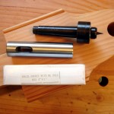
So, “here ya go, Shannon.” Shannon asked in a comment to a previous post about my intentions for the spinning parts. Let’s do the tailstock/puppet first. Many replicas of old time lathes want to use a large screw with a sharpened point as the tail center. I wanted a bit less drag and smoke! Live centers all seem to be attached to tapered fixtures. How would I support one of those? Some time ago, “TrialAndError” briefly mentioned using a “morse taper socket” in the lathe he built. It wasn’t until a week or so ago that I searched for such a thing on eBay and discovered they really exist.
(drop back one post to see a list of parts)
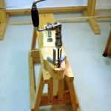

The morse taper socket I bought is simply a 1″ diameter chunk of stainless steel machined with a #2 morse taper hole, and then hardened. It is 4 inches long and includes a closed slot machined crosswise near one end. I assume this slot is used in applications where the socket moves within a quill. Beware when buying this piece. You can find them in the $30-$50 range on eBay, or for $9.70 at Amazon. Shop around.
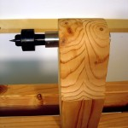
Drilling the 1″ hole through my puppet was a task best done on a saw bench. It is low enough to allow the right ergonomics of a very long auger in a hand brace. The short swing of the hand brace made for slow boring, but also made it easy to check constantly for accuracy.
The result is a very tight fit, requiring a block of wood and rubber faced mallet to drive the socket into the puppet. If, I find it moves under turning pressure, I’ll add a pin through that slot.

First Turning – a 24 inch object
A couple of posts back, I mentioned that the flywheel was cut round using a jig on the band saw. Well, that “round” was approximate. It wanted some truing, not a lot but enough to make me wonder about how well a belt would track. How to get it trued up? Makeshift time!
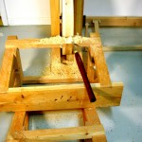
Finding a “tool rest” of an appropriate height was the first challenge. What the photo shows is an alternate use for the pair of saw benches I made ages ago. Flop them over on their sides and stack them “just so,” and the result is something good for supporting a newly arrived round nosed scraper. Not having a readily available treadling apprentice, I parked a chair beside the upturned saw benches, sat down, and treadled while leaning over and holding the chisel.
The wheel is now round. The drive belt won’t have to put up with a roller coaster ride. If you watch the wheel turn, you’ll see some side-to-side wobble, for which there are two responses: don’t watch, and it’s not enough to affect operation.

The Treadle Mechanism
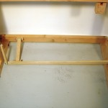
When I was much younger and more interested in high performance automobiles, one of the things I learned about was “unsprung weight.” That’s the weight of the car in the wheels, axles and undercarriage that isn’t moderated by the suspension system. A lot of unsprung weight dampens a car’s performance. The lower the amount of unsprung weight, the better performance can be tuned. This lathe takes that approach with the treadle. I’ve seen a lot of treadle lathes that have huge heavy treadle mechanisms. It seems to me that the effort that goes into operating a heavy treadle has the same dampening effect as excessive unsprung weight in cars. I can appreciate how a heavy flywheel adds momentum, but not if it has to drag along the dead weight of a heavy treadle. The lighter treadle was part of what drew me to this design.
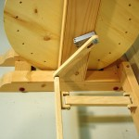
Three lightweight parts comprise the moving components, the treadle itself, a Pittman link, and a spacer bar that keeps the treadle parallel to the center line of the lathe. All three are of oak approximately 3/4″ by 1-1/2″ in measure. The treadle pivots on a 1/2″ diameter pin that’s held in the walnut block on the foot of the right leg. The pivot hole itself is 3/4″ diameter providing enough play for easy operation. The driving end of the pedal holds another 1/2″ diameter pin that engages the Pittman link. The bottom hole on the Pittman link is also 3/4″ diameter, allowing for a lot of angular movement. At the top of the Pittman link is a slot that is “a whisker” larger than 1/2″ wide, enough to ride freely on the crank’s 1/2″ diameter drive pin. Two u-shaped oak blocks anchor the spacer bar. The anchor pins are 1/4″ bolts fitted in 1/4″ holes in the blocks. The pivot holes in the spacer bar are 5/16″. Thinking these parts might need lots of wiggle room, I tried a much loser version and ended up with a lot of clunking. The tighter version runs smoothly and without any binding.
As before: Il meccanismo è molto scorrevole!

Treadle and First Turning
Wednesday, October 3rd, 2012
Roger Davis is a fortune teller, and a fellow Hoosier.
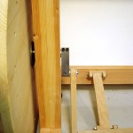
Roger and I met quite awhile back over on the Sawmill Creek forums talking about, what else, old tools. Not long after I published the last entry, Roger advised that the walnut crank probably wouldn’t last long. Now, it hasn’t actually failed but it didn’t take long for a bit of wobble to develop. Roger is a fellow woodworking enthusiast who also has day-job metal working skills and the equipment for prototyping aerospace instrumentation. Roger offered to make a “bulletproof” steel crank and I took him up on the offer. I’m absolutely amazed that he offered and acted so quickly. The crank is here and already in use. THANK YOU Roger!
By the way, for the spalted maple fans, be aware that there’s such a thing as spalted steel. This crank has a bit of spalting which I consider early onset patina.

Machined Crank Details
Lathe builders in 1805 didn’t know Roger Davis. They’d just have a blacksmith make them a simple crank and be done with it. I didn’t know Roger either when I built my lathe. He saw the blog entry showing the (pathetic) wooden crank I made, in the absence of a blacksmith, and suggested it wouldn’t last long. It didn’t. He then made me one that will never fail. It is solid!
Roger Davis is a fellow Hoosier with the good sense not to move to New York, a frequent visitor to Sawmill Creek (http://www.sawmillcreek.org/forum.php), owner of “a very complete machine shop” and self-proclaimed “lack of good sense,” an aerospace engineer by education (Yay Purdue!), former high school teacher (physics, cemistry, algebra), a builder of scientific instrumentation (start to finish) as his paying job, a builder and user of muzzleloaders as one of his hobbies, and variously proficient in gunsmithing, blacksmithing, woodworking hand tools, A&C furniture, cooperage and who knows what else. Bottom line: a generously good guy.
So, why am I telling you all of this? Josh, from the previous post, wanted more information about the machined crank, as did Matt in the comments on the post about Stephen Shepherd’s kit of parts.
Photos and a drawing tell most of what you need to know to make one. If you have the metal working equipment to cut a block of steel, cut a slot in it, drill accurately, and tap some screw holes, you can make one similar. For what it’s worth, the distance between pivots was simply an estimate (a little more than a tenth the diameter of the flywheel) and has worked very well. Roger didn’t specify the size of the cap screws, but they look to be 1/4 by 20 by 1 inch long. The only other thing not shown on the drawing, that’s very visible in the photos, is a dowel pin that retains the crank pin. The retaining pin is probably not needed on this particular crank since Roger built it to such close tolerances that the crank pin probably took several tons of pressure to seat as a “press fit.”
When installing on the flywheel axle, be sure to go back and forth between the two screws, as they each affect the other’s tightness until they are really tight.
This crank has been very solid. I’ve got hours and hours of use on the lathe and ZERO, Nada, NO slippage from the crank. It simply works! Thanks again, Roger.
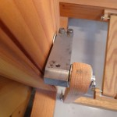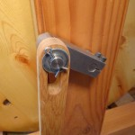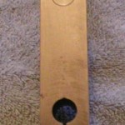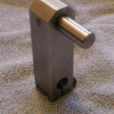

Spindle
Sunday, October 7th, 2012
You saw a quick shot of the spindle in an earlier post. Let’s take a closer look.
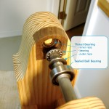
The spindle rides on 3 bearings. Two are ball bearings that sit in the walnut bearing blocks. The third bearing is a thrust bearing at the leftmost end. The thrust bearing offers a low friction way to absorb lateral pressure. The race that absorbs the pressure has a center hole too small for the spindle to pass through. The bearing ring in the middle is a very tight fit on the end of the shaft. The outer race has the same fit as the ball bearing. A photo details the parts for folks who haven’t seen this sort of thrust bearing.
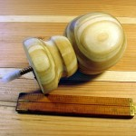
OK. What are we going to use for a drive pulley? There aren’t a whole lot of commonly available things of a decent diameter already having a 5/8″ hole bored through them. Hey, I could make one on a lathe! But, what to use to drive the lathe to make a drive pulley? Wander the aisles of the home center, asking “what about this, that, the other thing over there?”
Found it! A finial for a fence post looks like just the thing. Cut off the ball part. Bore a hole through it.
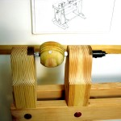
Fix it to the spindle, and get going. …and only $3.42. With all the boring I’ve done with the brace and Russel Jennings augers, I’ve gotten fairly good at putting holes near where I want them. Finding the center of a not-so-round pressure treated ball, and then drilling dead on the center was a near impossibility, and I lived up to that expectation. It’s not perfect. Yes Jeremy, it does wobble a bit, but it’s not headed for 70mph. Fixing it to the spindle is done with a couple of 1/8″ holes driven into the ball and partly into the spindle and #8 by 1-1/2″ wood screws. Crude but practical for a very temporary drive pulley.

Drivin’ It
Sunday, October 7th, 2012
My first “up close and personal” acquaintance with a steam traction engine was several(?) decades ago at an Antique Tractor show in Portland Indiana. More recently, I watched a 1913 Case engine drive a threshing machine at the Dakota County (Minnesota) fair late this summer. When these engines drive threshing machines or saw mills, power transfer is by use of a very wide and tremendously long fabric belts. I once asked an engine operator about how taut to make the belt. He advised, “only taut enough to keep it from slipping. Any tighter stresses axles and bearings.” The following video (not mine) shows an engine driving a threshing machine.

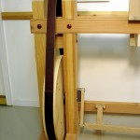
Wander around and look at shopmade wooden treadle lathes. You’ll find all manner of drive “belts.” Many use rope or leather cords. In doing my research, I saw a lot of lathes where the builder used extra idlers to add tension, usually to cords or ropes. Those look like very fussy contraptions.
Instead of using a narrow cord or rope, I decided to model my drive after the traction engines, with a wide leather belt. My intent was to eliminate the need for a fussy tension idler and to keep tautness to something less than a gnat’s ass stretched over a rain barrel. My drive belt is 2″ wide material from Tandy. The longest belting strips they offer are 72″ long. It takes the better part of two lengths to make this belt.
I made it long enough to be a snug, but not particularly taut, fit over the flywheel and temporary spindle pulley. It doesn’t slip, and the rounded shape of the spindle pulley sure keeps it on track.

Tool Rest & New Pulley
Tuesday, October 9th, 2012
Dovetails smuvtails! Every woodworking blog I read raves about dovetails. Dovetail this, dovetail that, fast dovetails, no-measure dovetails, 7 degree dovetails, 11 degree dovetails. Gheesh, you’d think woodworking revolves around dovetails. C’mon folks. Go take a close look at real 18th century furniture and the quality of dovetails in that stuff. The pre-machine era dovetails were a far distance from the holy grail woodworkers pursue today. Most of them were semi-hidden anyway, not as prominently featured as today. OK, rant over.
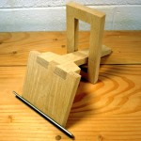
I don’t build furniture, so I’ve never felt compelled toward dovetail perfection. Then, along comes this plan that shows a tool rest held together with what? A dovetailed joint. Yes, I practiced a bit and did more than the one shown here. I’m happy getting it to look a bit better than Dave Letterman’s front teeth. It is a surprisingly solid join. No wiggle!
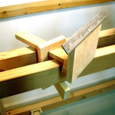
This particular part of the lathe is very close to the plan, except for part thickness. The plan calls for full inch stuff, which I don’t have and did not want to go get. I did upgrade from constriction fir to red oak for the rest and the clamping collar. I’m using simple fir for the wedges, seeing them as sacrificial. This rest has a fair degree of movement and positioning capability. The plan shows a hole in the far end of the horizontal piece, which is intended to hold a bolt upon which a face rest can be built. I’ve skipped that for now.
OK Ralph. The first real turning is a good drive pulley/wheel to replace that fence finial.
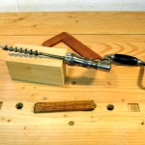
The challenge was to make a piece with a 5/8″ axial hole. Having neither a jawed chuck to hold a turned piece, nor a way to feed a drill bit along the center line, I improvised. The turning block comes from a section of laminated material identical to the lathe feet, essentially a pair of 2x4s, about 7 inches long. I drilled a 5/8″ hole through the center of the block with an auger bit, being careful to just pierce the far end with the lead screw. That small hole in the far end served as a centering point for the spur drive bit.
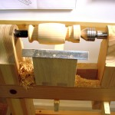
A live center slipped into the end of the block with the start of the 5/8″ hole. Then, came the bit of the old fogie learning to hop about on one leg whilst pumping the treadle with the other and trying to learn how to manage turning tools while bouncing, swaying, and fighting off vertigo. My wife stopped by to watch and snicker for a few minutes, and fortunately got bored and left.
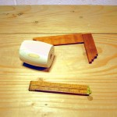
I messed about quite a while trying out several new Wood River turning tools. As an aside, these tools arrive needing a good honing. Actually that’s not difficult, and once honed they seem to work well. Yet, I’m a novice turner and anything that can change the shape of the wood impresses me.
Yes, I made a variety of “interesting” surfaces along the way. My best work was with a 1/2″ roughing gouge. My worst, of course, with the skew. I don’t yet have a parting gouge, so ended up hand sawing the ends away.
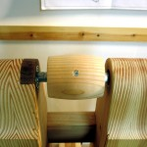
The temporary ball pulley/wheel demonstrated the value of a crested surface in helping keep the belt running nicely. So, I made this piece with a crest, although not as extreme as the temporary part. I decided to use the same simple mounting, a screw through the wheel into a hole in the spindle. The wheel ends up a bit smaller than the earlier part, requiring the belt to be shortened a bit and restitched.
The first turning can be called mostly a success. Mostly because even though it was round while between centers, it is not perfectly round when mounted on the spindle. As careful as I was in the improvising, the spindle hole did not get perfectly mounted between centers. I suspect it is due to “play” in positioning the tail puppet. I’ll have to learn how to make that more precise.
Now, I’m like the dog that caught the car. What next?
Lastly, a few words for Kari: Here’s a lathe you can like. Human power can’t get it turning fast enough to hurl heavy objects at your head. If/when you catch the point of a skew chisel, there’s not enough momentum to grab the chisel out of your hands and throw it back at you. Instead, the belt slips until you easily regain control. In short, it is a non-lethal lathe.

Adjustable Tool Rest
Saturday, October 20th, 2012
An Improvement. The tool rest was “built to plan.” The only adjustment I made was to change the height commensurate with how much my centers varied in height above ways from the original plan.
It worked. Yet, it felt like I was always creeping up on the work from underneath. In other words, the tool rest was too low. I temporarily shimmed it up with various bits from the scrap bin. Better!
OK. Let’s keep going. Make it adjustable. Cut off the top inch or so. Just for interest, cut a couple of nice semi-circles in the remaining base. Drill 1/4″ holes at the centers of the semi-circles. Make a new piece, same width. Cut it’s upper edge to 45 degrees and attach the metal rest plate. Cut two 1/4″ slots. Assemble with 1/4″ carriage bolts and wing nuts. Think about replacing the wing nuts with something prettier some day.
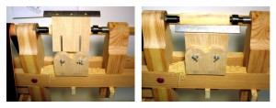
Molto meglio! Benissimo!
Oh! Before you ask about the first project, Ralph. I’m still learning how to address spinning objects with sharp chisels. So far, and for a bit more time, all I’m making is mulch.
Notes:
- Can I make a sander attachment?
A sander attachment shouldn’t be too difficult … a disc and any ole (appropriately thick) block of wood to act as a table across the ways. Good idea!
- What is the right height for the lathe?
It seems the basic height of the lathe will need the operator to stand, or maybe sit atop a high stool. We’ll see.
We’re told that nature takes things away from us as we grow older. One of those things is balance. Try a little experiment. Stand up, lift one leg, and stand on one foot for awhile. OK? Now, close your eyes. Still OK? The good news is that if this exercise makes you tipsy, the skill can be regained with regular practice. I’ve been practicin’. So, we’ll see how it is to stand on one leg, pump up and down with the other, all the while swinging a sharp object around a spinning piece of lumber. Might need that stool.
My lathe has been raised a bit (blocks under the legs) to bring the center line to the same height as my elbows. Your arm bent at right angle and the tool it holds should meet the center line nicely.
- How does the thrust bearing work?
The thrust bearing works by not allowing the shaft all the way through the bearing. It cups the end of the shaft and transfers the pressure to all the balls in the bearing, and therefore to the race. That’s how it absorbs the “thrust” from the tailstock.
What did you make the shaft out of?
The shaft is very simple 5/8″ cold rolled steel rod from Home Depot. I was fortunate enough to pick up a piece that runs true. Shannon Rogers laments not having the same luck and replaces his shaft with a rod from McMaster Carr.
- How did you make the machined crank?
That machined crank piece was sheer good luck and the generosity of a kind blog follower. Like you, that was a part that held me back for quite a while. Stephen Shepherd’s plans describe a shaft bent into a crank shape by a blacksmith. We have none of those sorts of people here. My first attempt was a wooden crank, but it wasn’t secure enough to stand the load. All I can recommend is find a welder, or search the McMaster Carr catalog.
hmmmmmm…? Maybe crank handles?
- Will I get all the parts I need if I purchase Stephen’s metal parts package?
Yes, if you purchase Stephen’s metal parts package, you will have everything but the wood. Be aware, the specs are for an 1805 version and the hardware matches that era. For example, the headstock is a simple mandrel in a tube, not the more modern shaft and bearing arrangement I used. Not that the modern stuff is really needed. The 1805 version works great.
The machined crank that I refer to is another modern version of the flywheel crank. That’s the hardest part of the whole build and Stephen provides it in his kit. I didn’t have a blacksmith or welder who could make one for me. So, I started with a wood substitute that didn’t last long. Another fellow saw it and made me the metal / machined version. The crank in Stephen’s kit will do perfectly.
- Will the treadle lathe be powerful enough?
I’ve turned objects (lidded boxes, for example) up to 6: in diameter and the lathe and my right leg performed very well. Spindles are easy. They spin fast and are easy to shape. As you might expect, you’ll need to take shallower cuts and more of them, (and keep your tools very sharp) but I don’t see that as a deal breaker. Make the bed as long as you need for the length of spindles you intend to turn.

- How taut should the belt be? I am concerned about slippage.

The belt is not overly taut. It can be squeezed all the way into the frame with no stress. Other than the width, another reason it works so well is that the inside of the belt is not finished smooth. It’s a bit rough, grippy, and I left the wheels rough too. BTW, Tandy sells their belt leather in two grades, unfinished and finished. One would think the finished more expensive, but that was not the case when I bought this belt material. The finished stuff was on sale for about 10% less less than the unfinished. It’s also thick enough that it’s not stretching.
Yes, there’s some slippage, but only when I really “jam it” with a stupid chisel move. There’s plenty of torque to make cuts I really didn’t want to make.
That’s with almost no stretch to getting the belt over the wheels. It’s notably slack. I attribute the good performance to width. There’s a lot of contact area.
The belt actually feels a bit slack. Yet, a moderate push at the midpoint yields only about an inch. You’ll likely find that you have to “sneak up” on the correct belt tension. I did. When the belt tends to slip too easily, ease it off of the flywheel, cut the bindings and about an 1/8-1/4″ off of one end and rebind. It takes only about 10 minutes and once right seems to hold for a very long time.
I thought that a lot easier than building extra tension arms and springs and such.

- Can I just use a grinder to sharpen my tools?
One thing I noticed is that my tools need to be a lot sharper with the foot powered lathe than the tailed kind. I can get away with coming off the grinder on my Shopsmith, but for potato-power, I go to my stones.

- Did you add a crown to your wheel?
The crown was added since those photos were taken. It is a slight crown, with each edge is about 3/16” lower than the center. We’ll see how it works or if more is needed.

